* 1. **Light up a colorful water lights on body of robot**

**1.Preparation**

1.You should learn about the position of the colorful lights in the body of hellobot；

2.You should learn about the micro:bit pins connected to the colorful lights in the schematic.

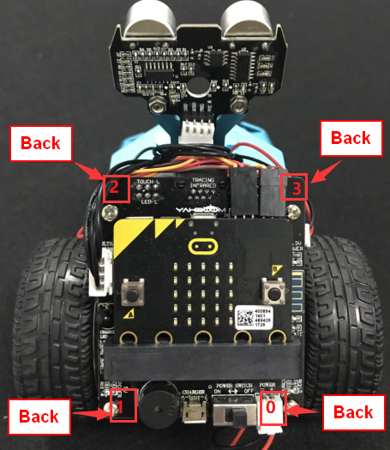

1-1-1 colorful lights on body of hellobot（back）

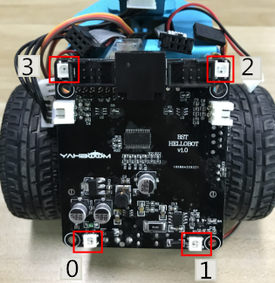

1-1-2 colorful lights on body of hellobot

We can make different colors of light and brightness by programming.

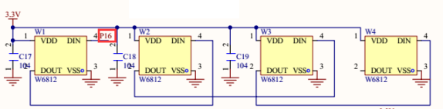

1-1-3 schematic

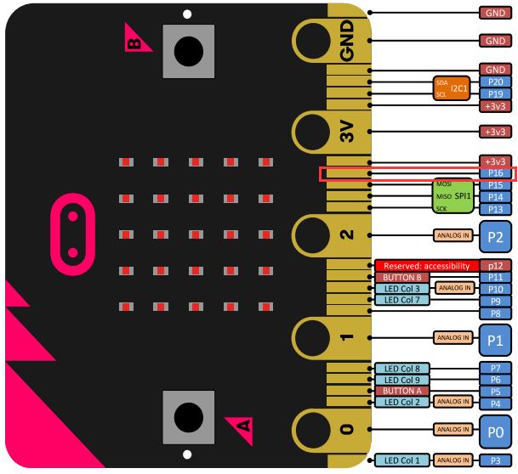

1-1-4 Pins of Micro:bit

From the schematic diagram in P1-1-3, you can see that the colorful lights is connected to the P16 of the Micro:bit.

Note:In the bottom layer of the HelloBot package has been set parameter for the user, you can directly drag the colorful lights building blocks.

1. **Learning goals**

The colorful lights is a combination of three colors of red (R), green (G), and blue (B). The controller can control the output and the brightness of each color to achieve a combination of different colors.

HelloBot body possess four colorful lights, this course we will study how to light a colorful light on the body by programming.

**3.Programming**

3.1 Programming online

**1) You should use the USB cable to connect the micro:bit to the computer, at this point, the computer will have a micro:bit U disk. You need to open it, click micro:bit website, then entered the micro:bit website** or you can enter the URL directly in your browser: http://microbit.org/

2) After entering the programming interface, you need to click Add package and copy the HelloBot package URL: https://github.com/lzty634158/HelloBot to the input field, click to confirm the add package. Then you can use the blocks of the HelloBot package.

3.2 Programming offline

1) You can double-click to use it. As shown in the following figure.

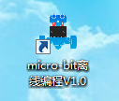

2) After entering the programming interface, you need to click Add package and copy the HelloBot package URL: https://github.com/lzty634158/HelloBot to the input field, click to confirm the add package. Then you can use the blocks of the HelloBot package.

**Note: The package only needs to be added once. If you have added packages in the previous lessons, this course does not need to be added repeatedly.**

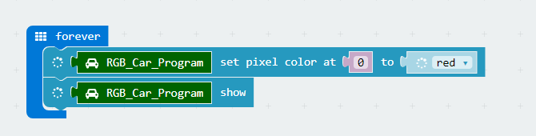

1-1-5 total program

The locations of blocks in the total program are shown in the following figure.

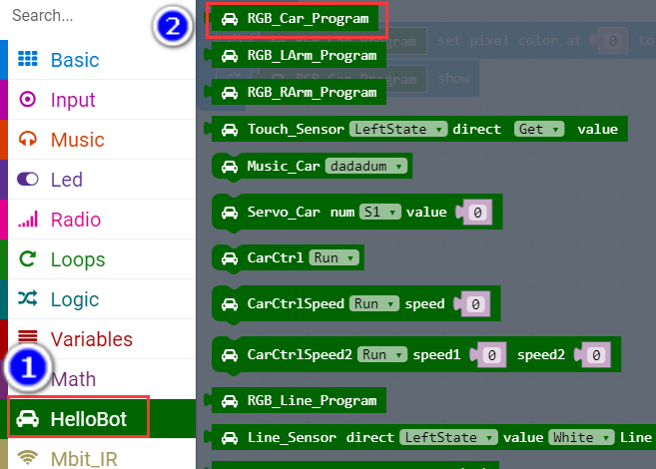

1-1-6

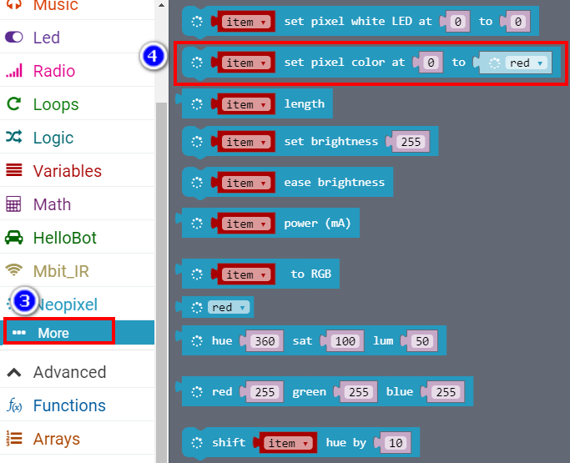

1-1-7

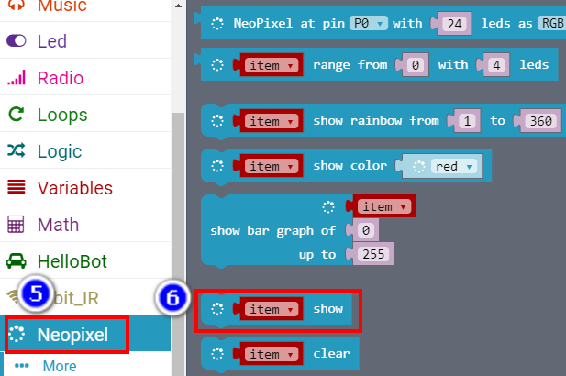

1-1-8

**4.Download programming**

You need to make sure that the micro:bit development board is connected to the computer. Then you should click on the download in the lower left corner as shown in P 1-1-9 to download the program to micro:bit.

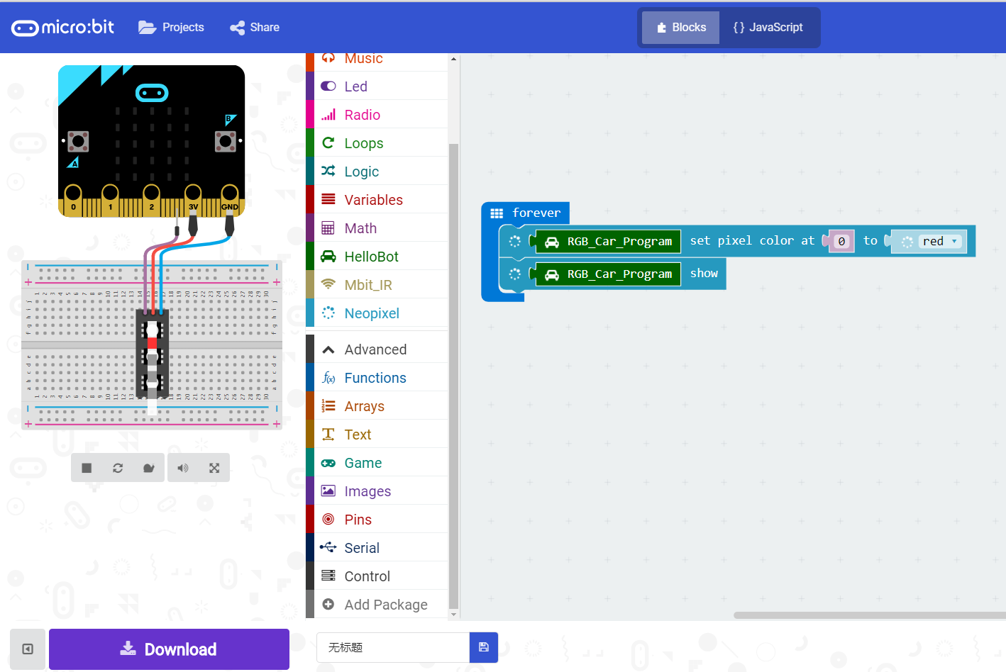

1-1-9

**5.Phenomenon**

After the code is uploaded. You can see that the colorful lamps in the lower right corner of the HelloBot emit red light. In addition, you can also modify the program to choose to light up different lights and emit different colors of lights. As shown in the following figure.

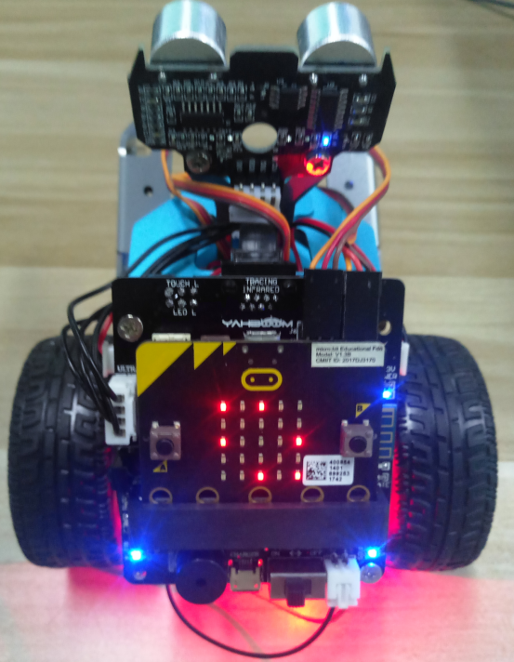

1-1-10